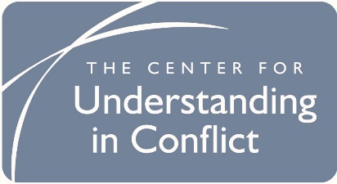
Online Mediation Session Details

Zoom Login info for our meeting

Join Zoom Meeting (use this to login from a browser. You will be able to use video and audio)
https://zoom.us/j/______________
Meeting ID: | [meeting ID]
Password: | [password]

One tap mobile (audio only from your smartphone, no video)
+16699006833,, ______________# US (San Jose)
+13462487799,, ______________# US (Houston)

Dial by your location (audio only from any phone, you will need to enter the meeting ID shown below)
+1 669 900 6833 US (San Jose)
+1 346 248 7799 US (Houston)
+1 312 626 6799 US (Chicago)
+1 646 558 8656 US (New York)
+1 253 215 8782 US
+1 301 715 8592 US
Meeting ID: | [meeting ID]
Find your local number: https://zoom.us/u/apSWG1Wnw

Zoom links that may be helpful

https://support.zoom.us/hc/en-us/articles/201362193-How-Do-I-Join-A-Meeting-

https://support.zoom.us/hc/en-us/articles/115002262083-Joining-a-test-meeting

https://support.zoom.us/hc/en-us/articles/200941109-Attendee-Controls-in-a-Meeting

https://support.zoom.us/hc/en-us/articles/203024649-Video-Or-Microphone-Off-By-Attendee

https://support.zoom.us/hc/en-us/articles/115005769646-Participating-in-breakout-rooms

